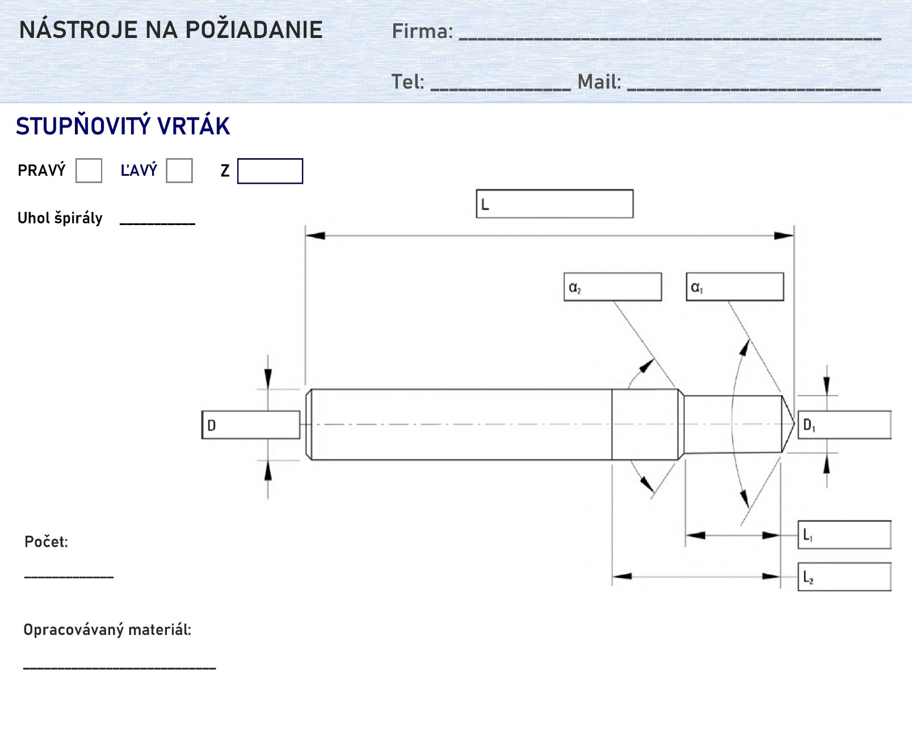

POZNÁMKY:

_______________________________________________________________________________________________________________________________________________________________________________________________________________________________________________________________________________________________________________________________________________________________________________________________________________________________________________________________________________________________________________________________________________________________________________________________________________________________________________________________________________________________________________________________________________________________________________________________________________________________________________________________________________________________________________________________________________